Issue 1 - No user-friendly error message
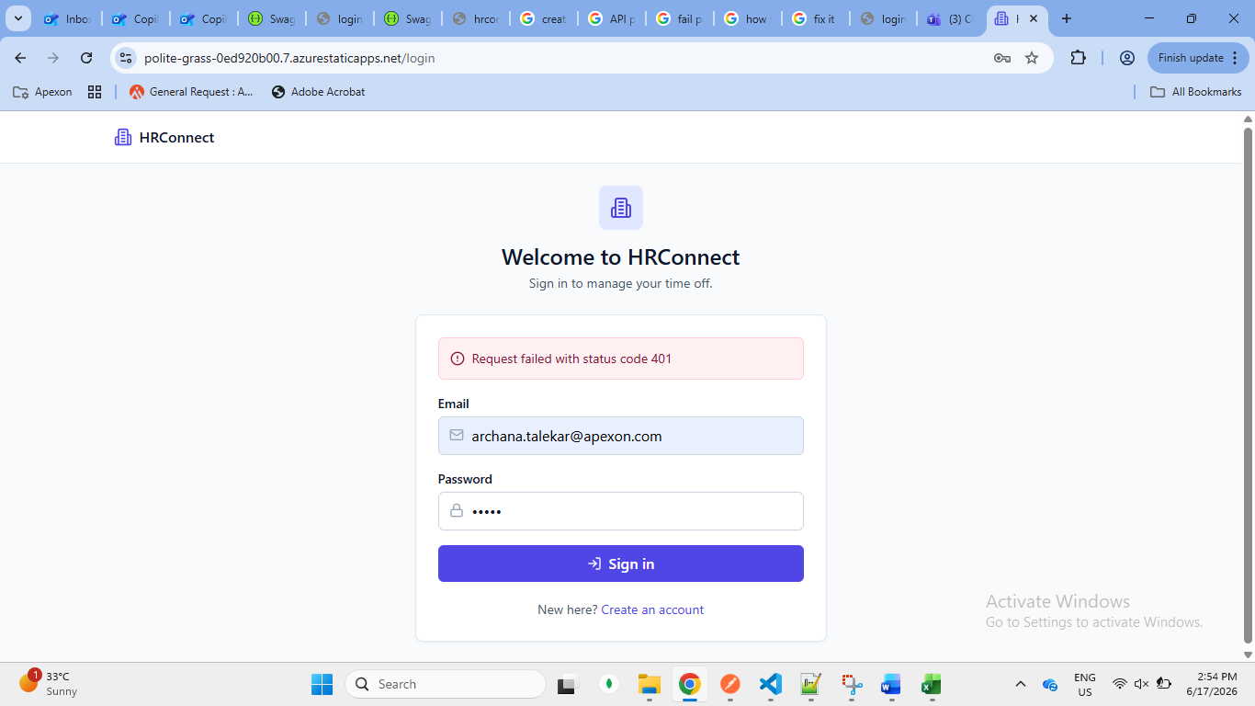
Issue 2: Joining date related
Default date is provided it should be watermark – dd/mm/yyyy
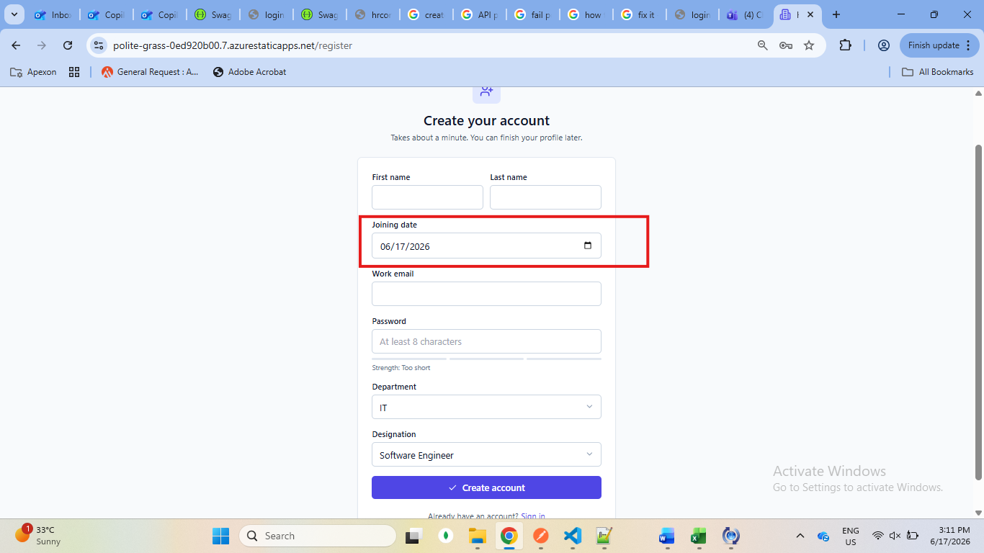
Wrong date is accepted
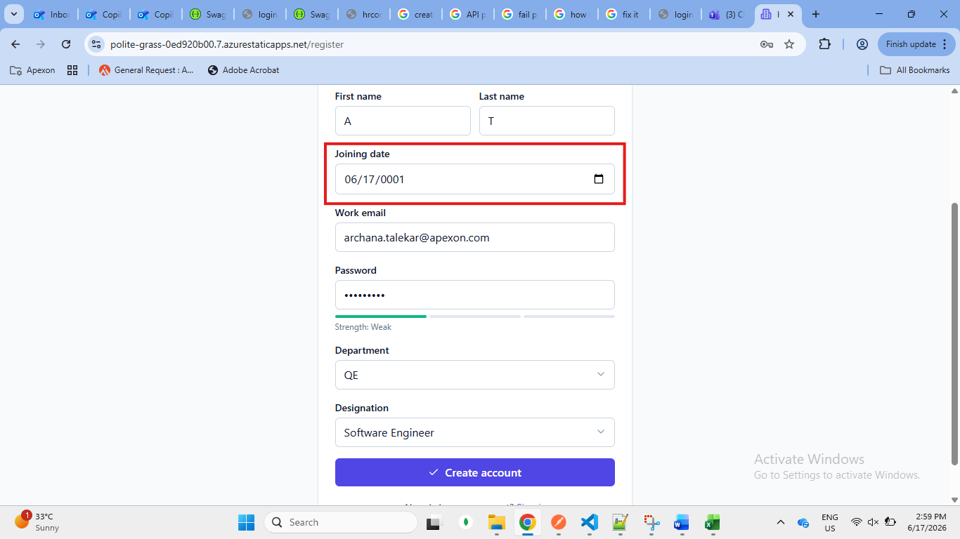
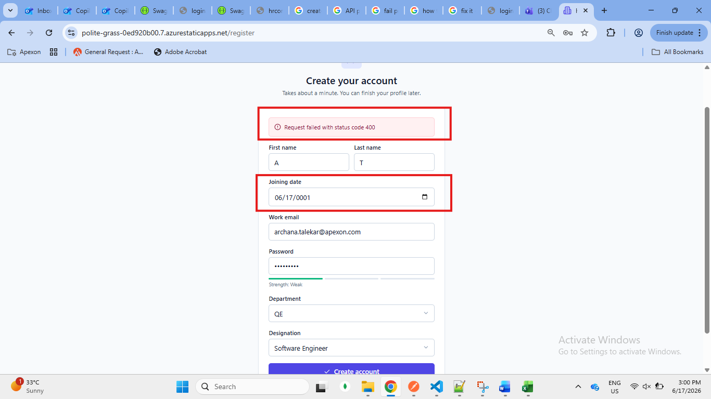
Issue 3 – Full name
Only special characters are accepted
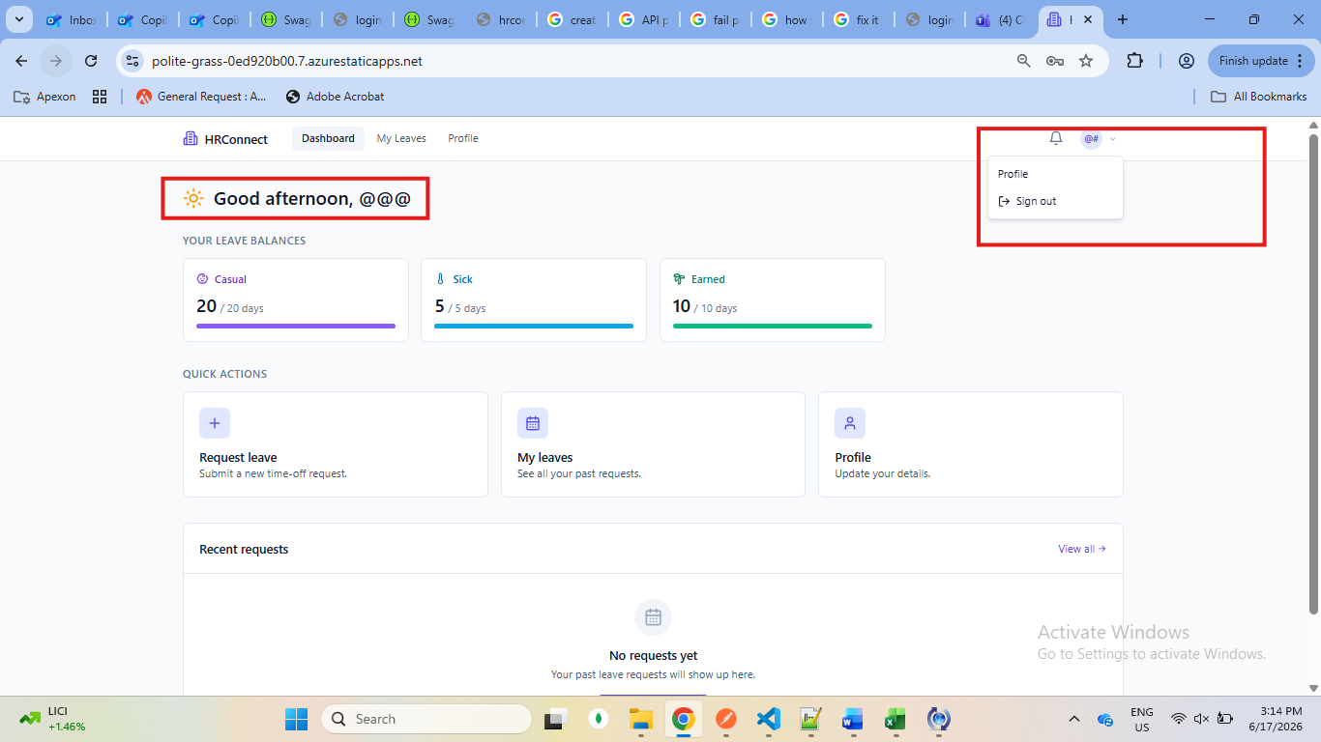
Issue 4: Wrong leave calculation
Leaves are not deducted
First request submitted
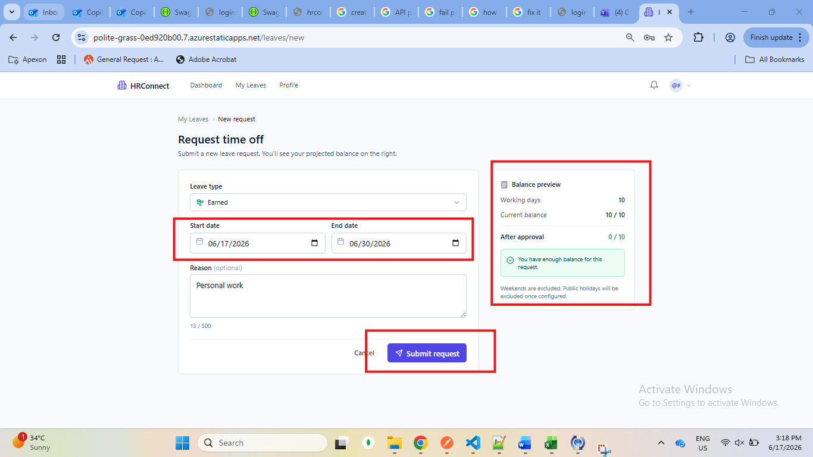
Second request
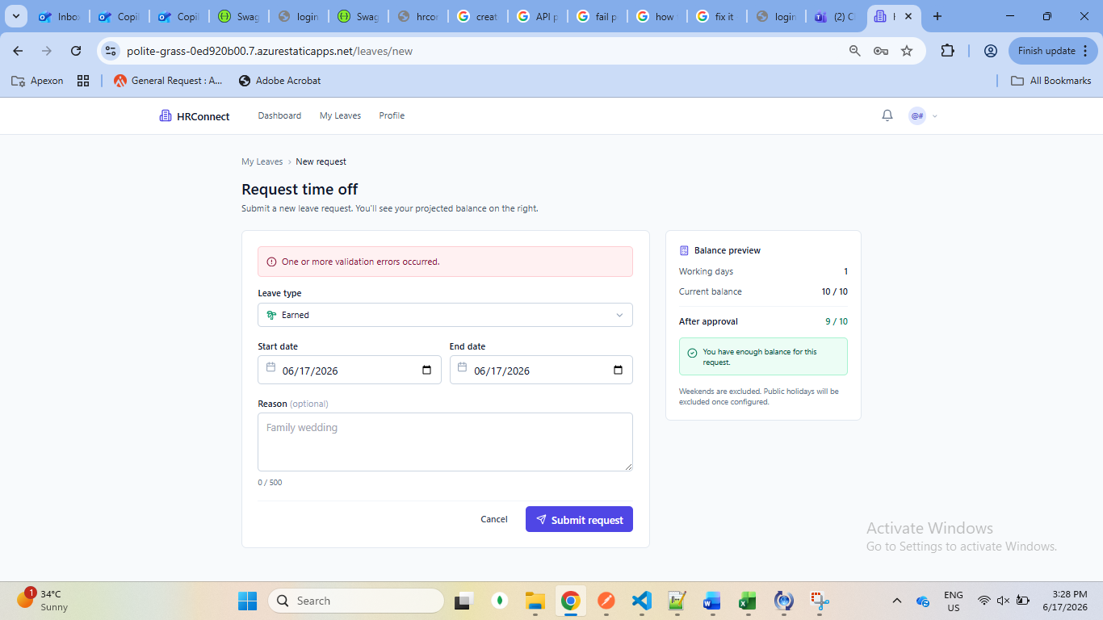
My leaves screen
Invalid characters
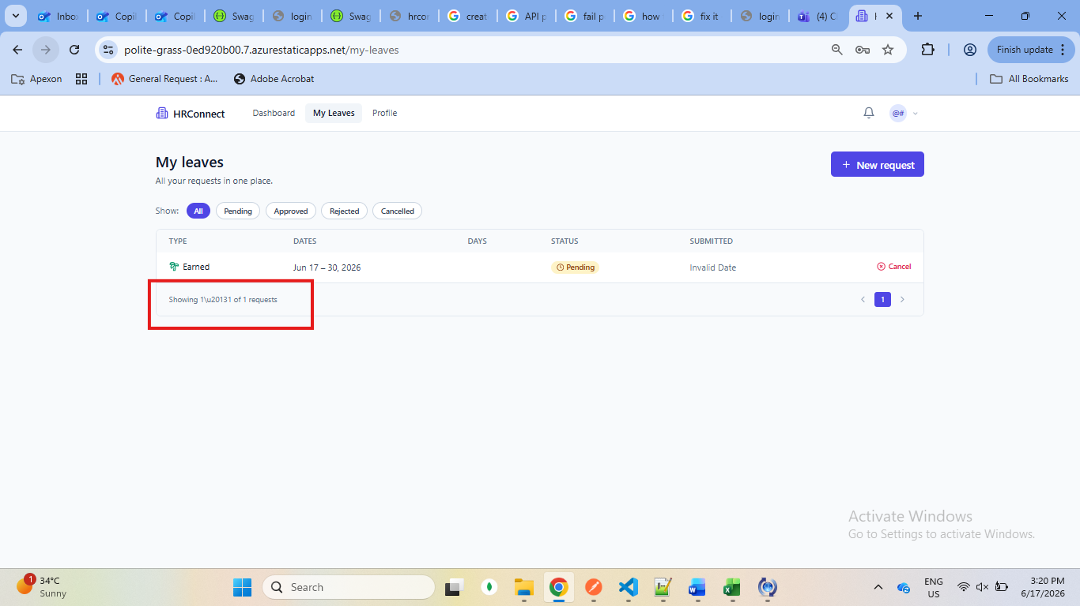
No days mentioned
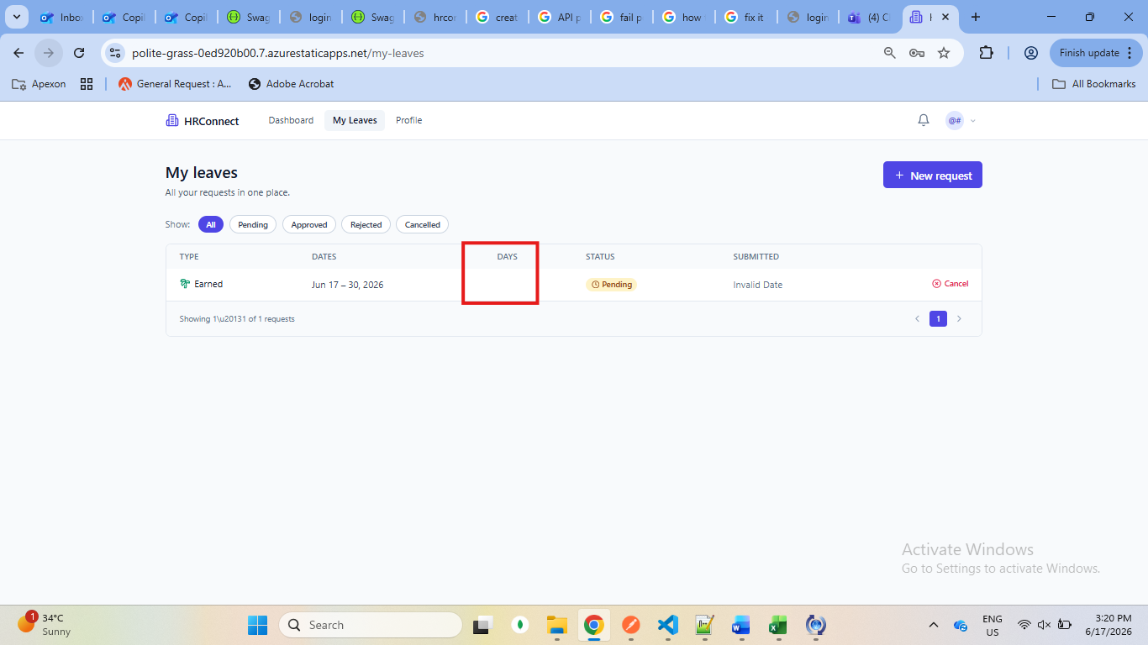
Cancel leave failure
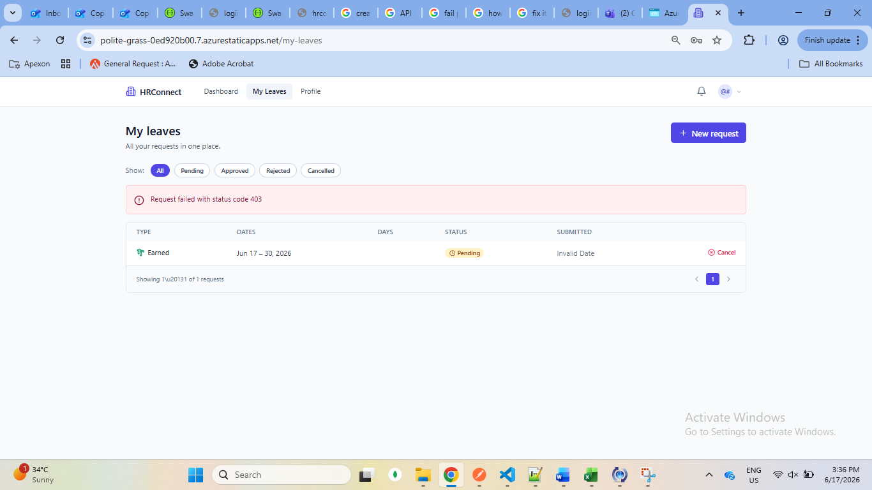
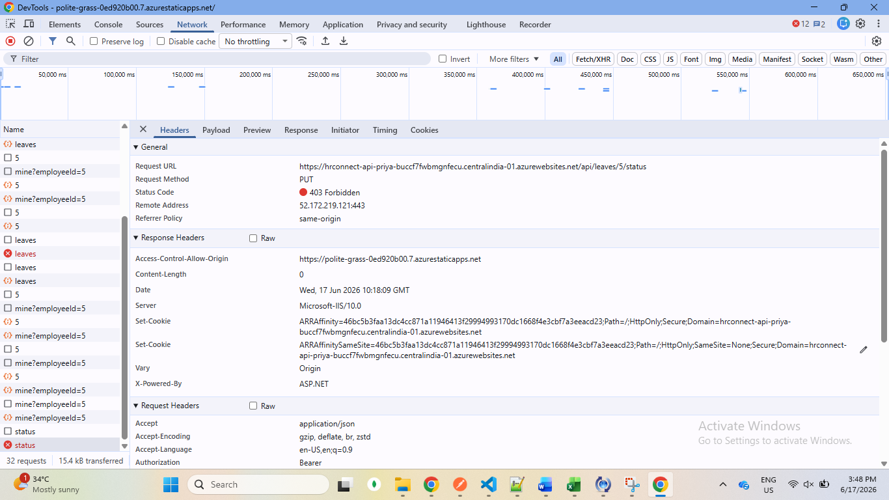
Unable to create leave without reason
"JSON deserialization for type 'HRConnect.API.DTOs.CreateLeaveRequestDto' was missing required properties including: 'reason'."
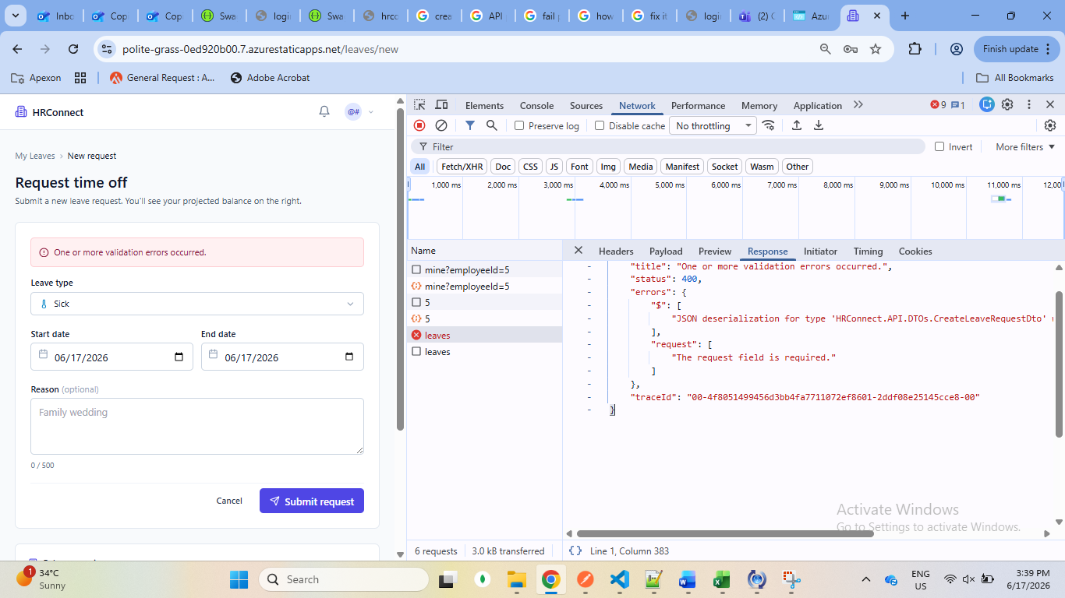
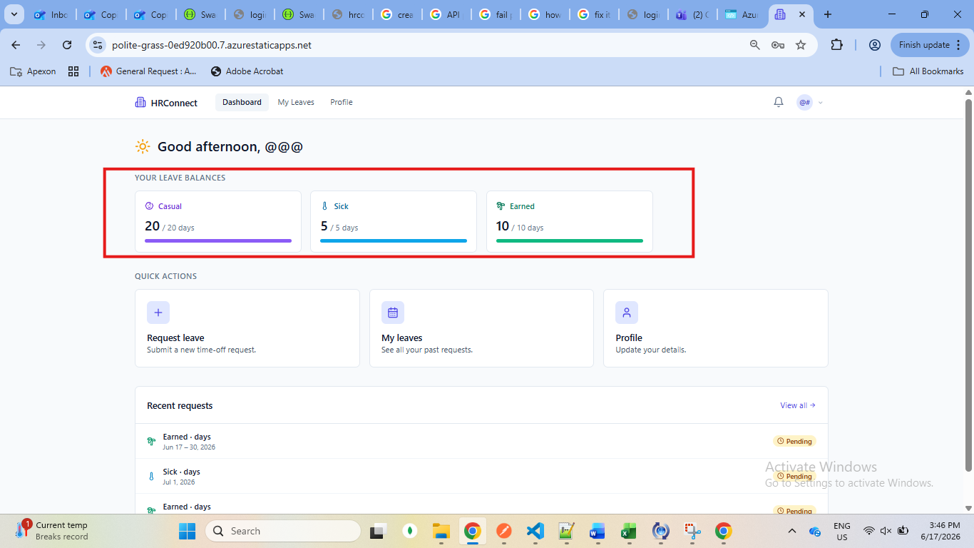
Leave balance is not updated

Able to select weekend in leaves

